Sphere-Based Composite Solids Formed by Addition

Definition
# Source: AI Source: Provided by: [Data Path: Persons Table -> ID Column: 1, Name_En Column: Motasem Essam] -> From: [ChatGPT] on [7/25/2026]
Sphere-Based Composite Solids are three-dimensional geometric solids formed by joining two or more spheres, or by combining spheres with other geometric solids.
The spherical components may differ in radius, diameter, position, and orientation. They can be joined through contact regions, partially intersecting regions, or combined with other solids to create a larger composite structure.
Examples include:
- Two equal or unequal spheres joined together.
- A hemisphere attached to a cylinder.
- A sphere placed on top of a prism.
- Multiple spheres arranged around a central sphere.
- A sphere combined with a cone or another curved solid.

Simple Definition
# Source: AI Source: Provided by: [Data Path: Persons Table -> ID Column: 1, Name_En Column: Motasem Essam] -> From: [ChatGPT] on [7/25/2026]
A sphere-based composite solid is a 3D shape formed by combining spheres with other spheres or geometric solids.

Geometric Representation
# Source: AI Source: Provided by: [Data Path: Persons Table -> ID Column: 1, Name_En Column: Motasem Essam] -> From: [ChatGPT] on [7/25/2026]
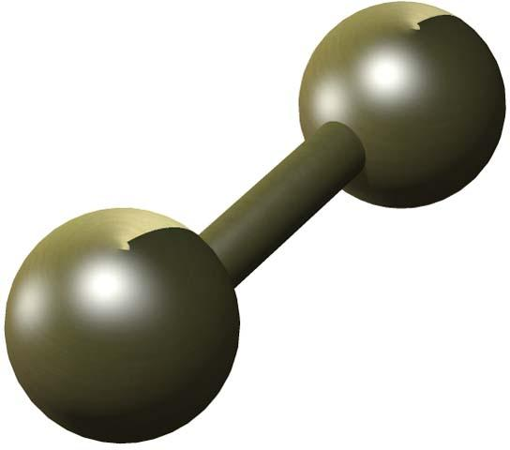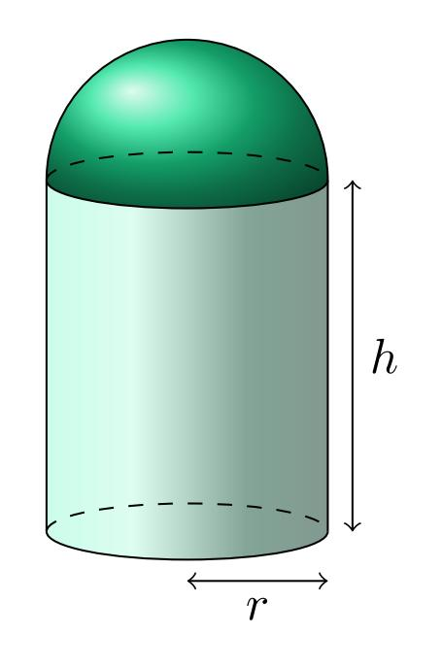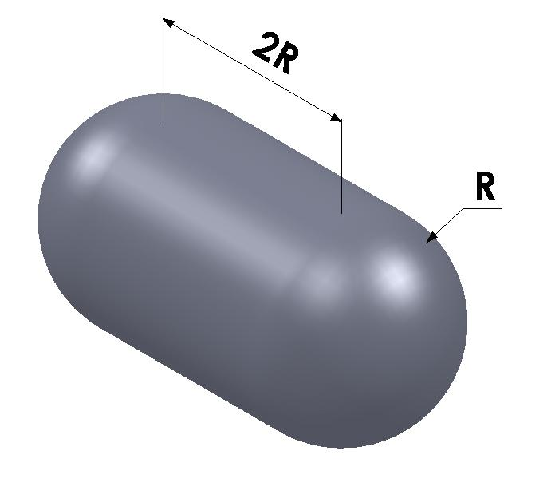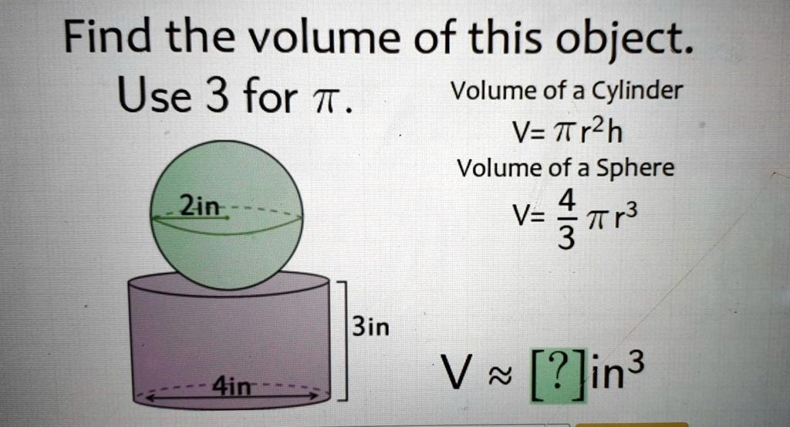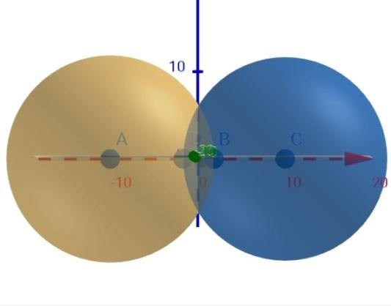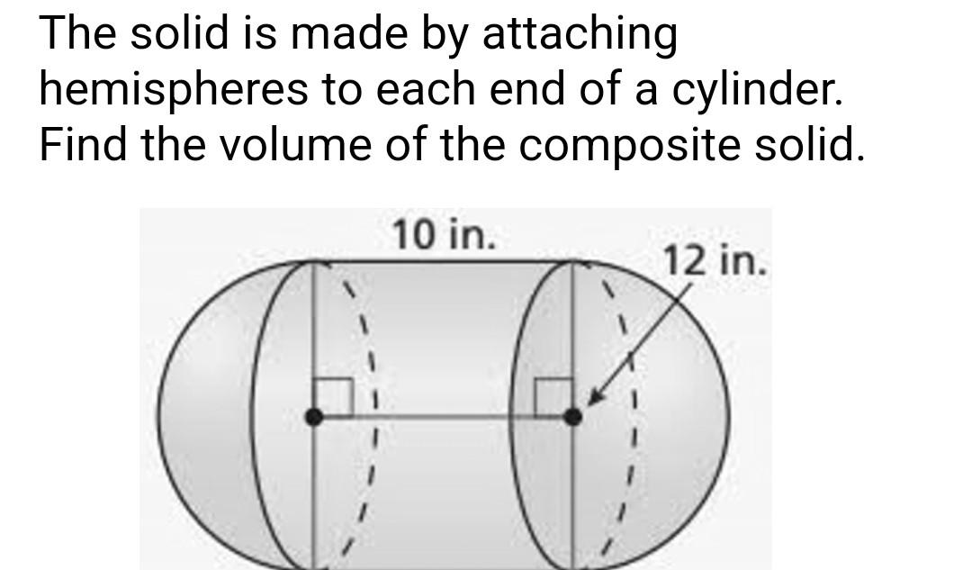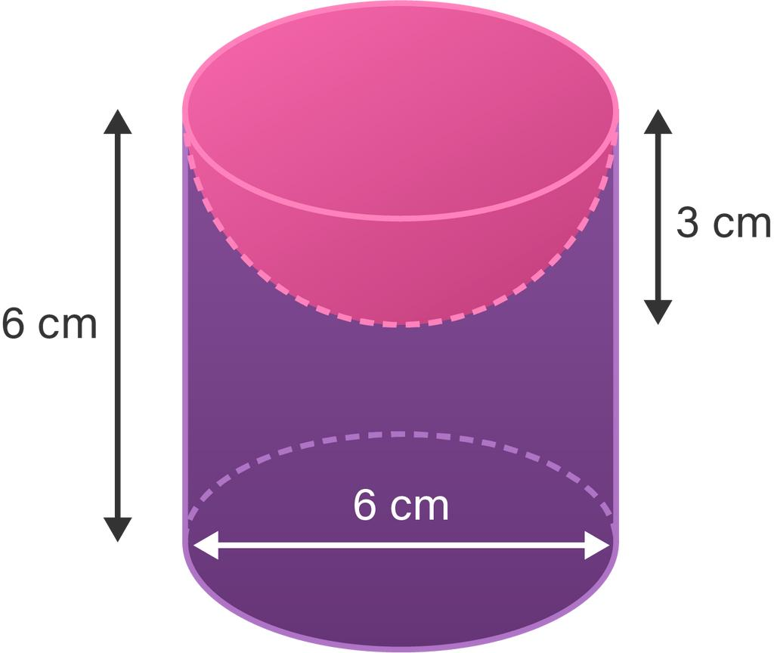
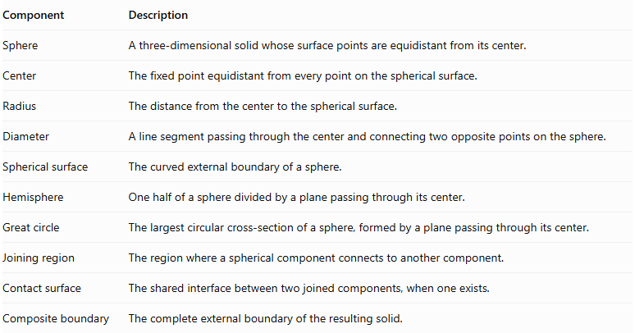
Component | Description
Sphere | A three-dimensional solid whose surface points are equidistant from its center.
Center | The fixed point equidistant from every point on the spherical surface.
Radius | The distance from the center to the spherical surface.
Diameter | A line segment passing through the center and connecting two opposite points on the sphere.
Spherical surface | The curved external boundary of a sphere.
Hemisphere | One half of a sphere divided by a plane passing through its center.
Great circle | The largest circular cross-section of a sphere, formed by a plane passing through its center.
Joining region | The region where a spherical component connects to another component.
Contact surface | The shared interface between two joined components, when one exists.
Composite boundary | The complete external boundary of the resulting solid.

Types of Sphere-Based Composite Solids

Sphere-Based Composite Solids Formed by Joining Spheres
# Source: AI Source: Provided by: [Data Path: Persons Table -> ID Column: 1, Name_En Column: Motasem Essam] -> From: [ChatGPT] on [7/25/2026]
These solids are formed by combining two or more spherical components.
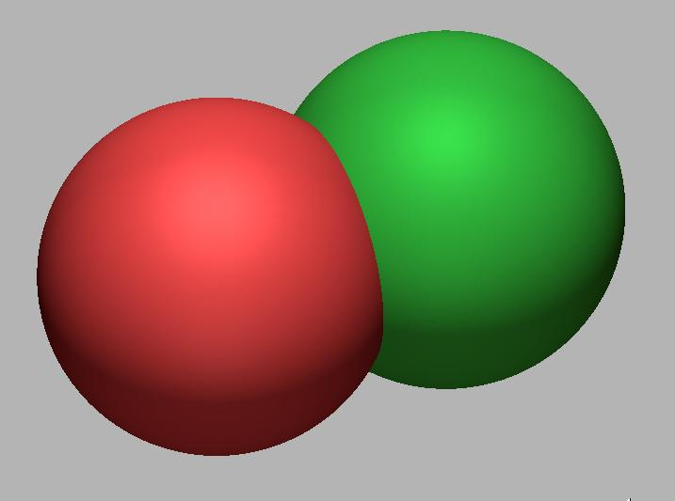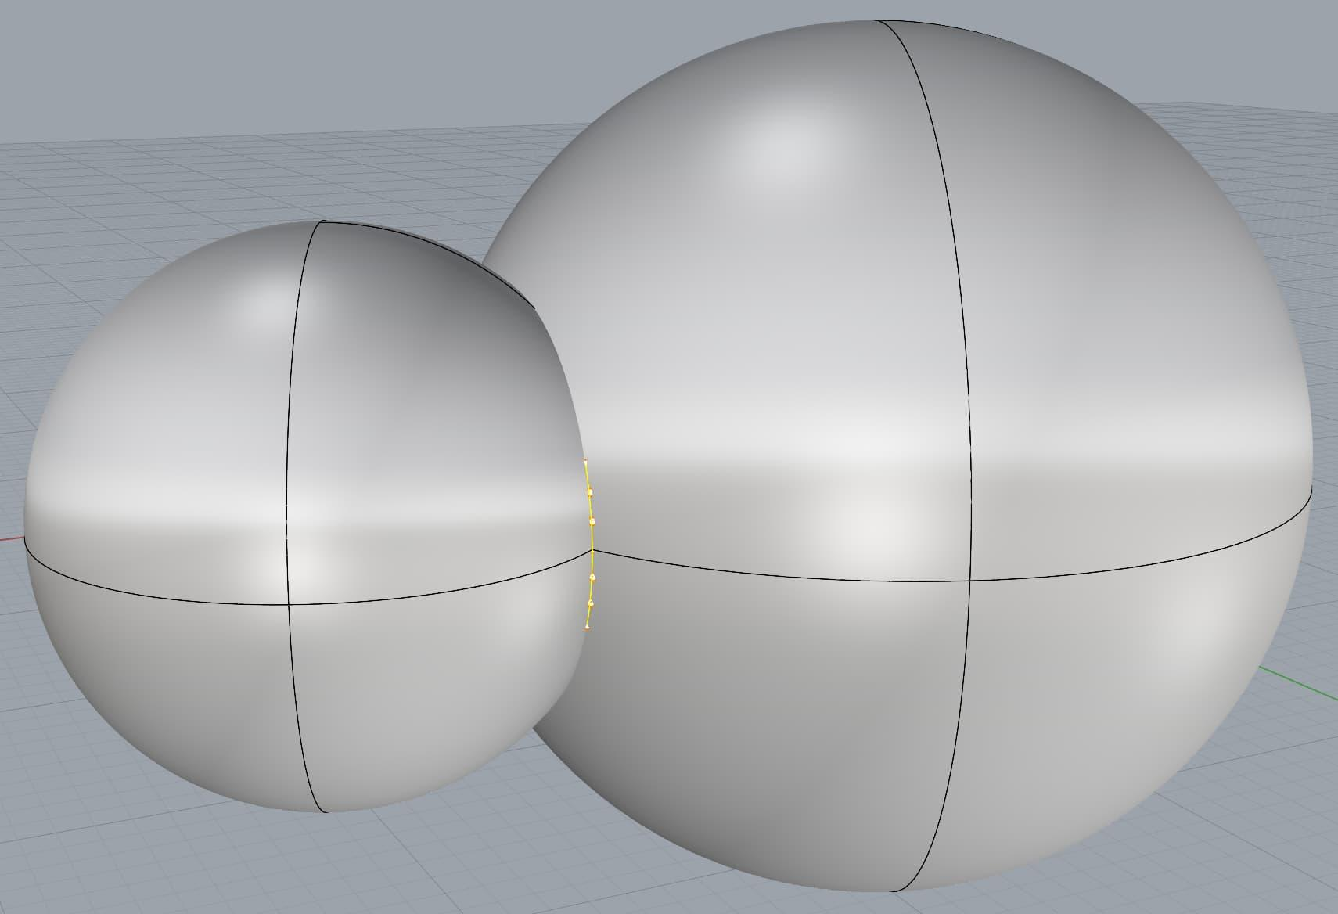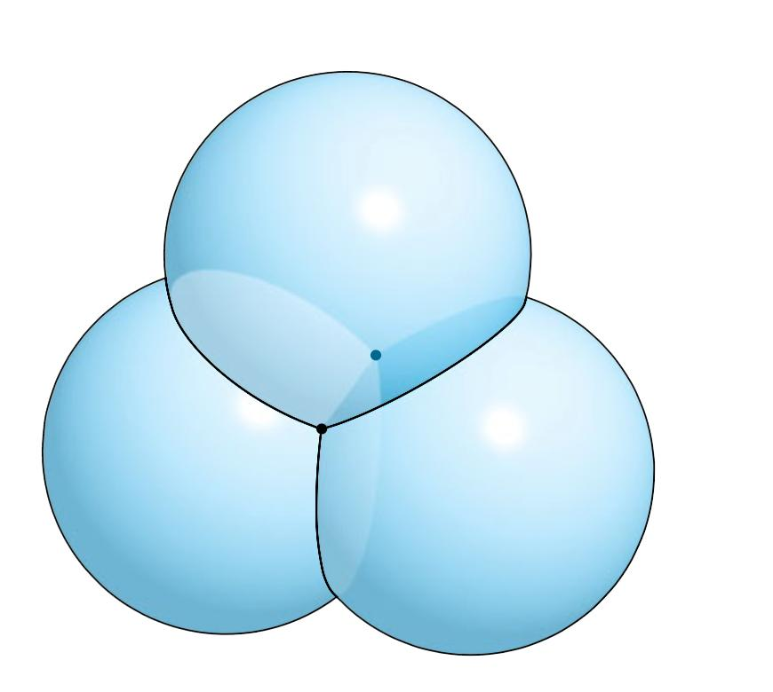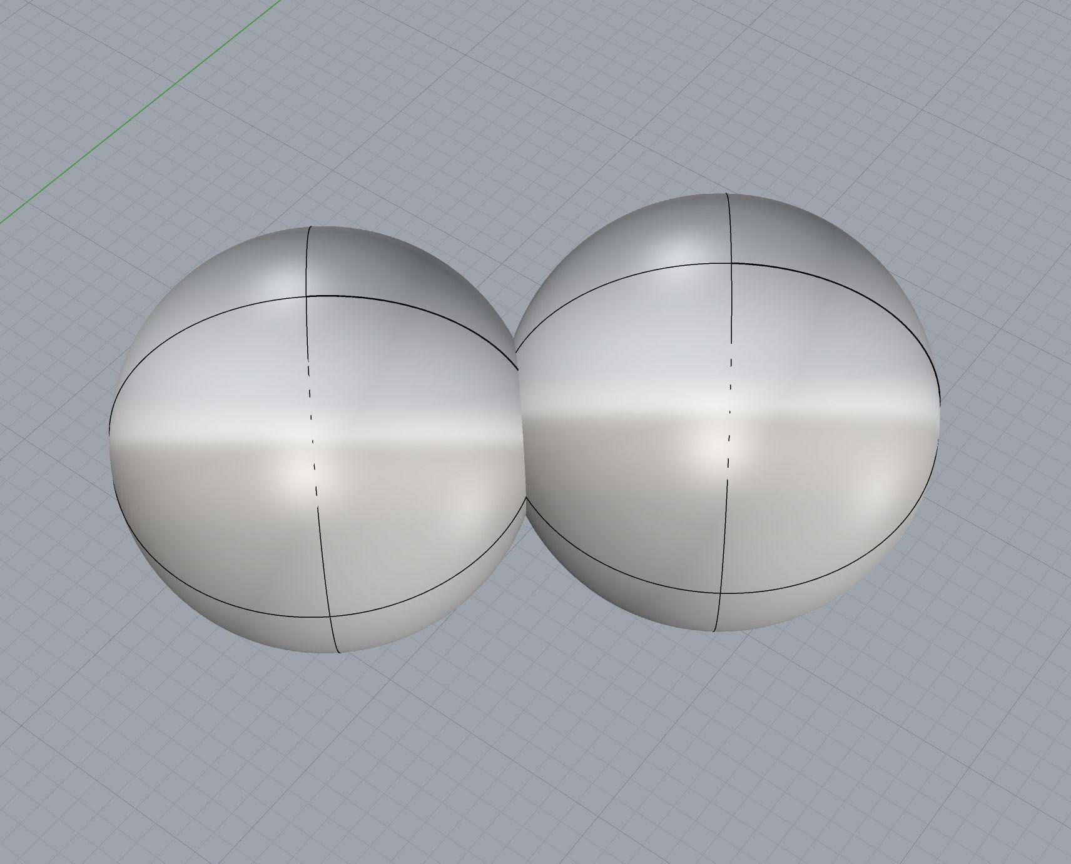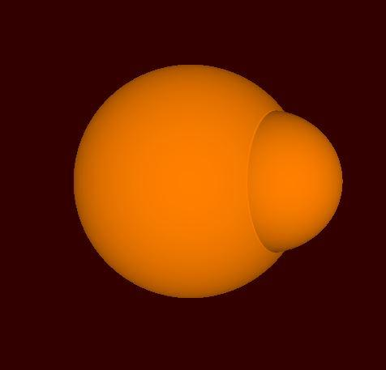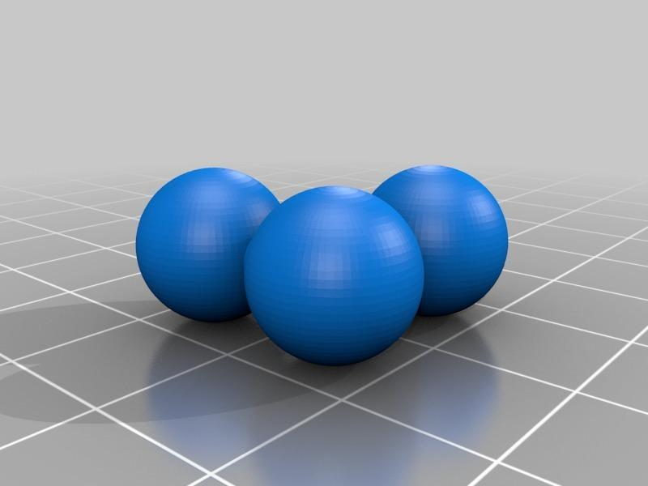
Examples:
- Two equal spheres touching each other.
- Two unequal spheres connected through a joining structure.
- Three or more spheres arranged in a connected group.
- Multiple spherical components forming a larger composite object.
Note: Two spheres that only touch at a single point have zero-area contact and are not joined across a face. Their union is still a combination of two spherical solids, but it is not a face-connected solid.

Sphere-and-Hemisphere Composite Solids
# Source: AI Source: Provided by: [Data Path: Persons Table -> ID Column: 1, Name_En Column: Motasem Essam] -> From: [ChatGPT] on [7/25/2026]
These solids combine a complete sphere with one or more hemispherical components.
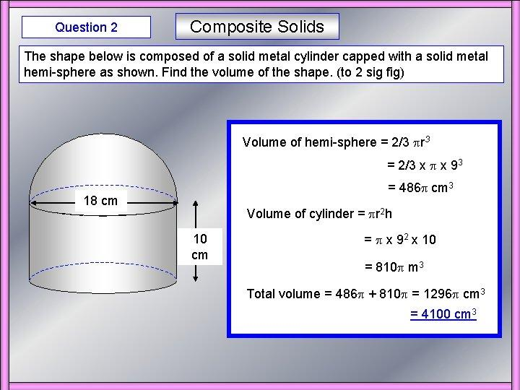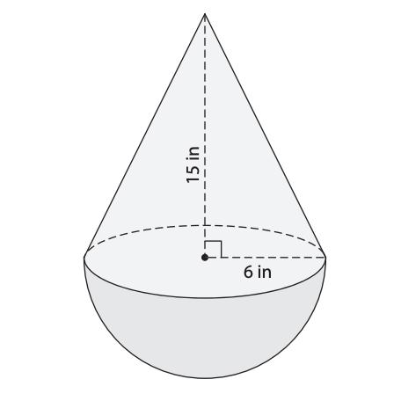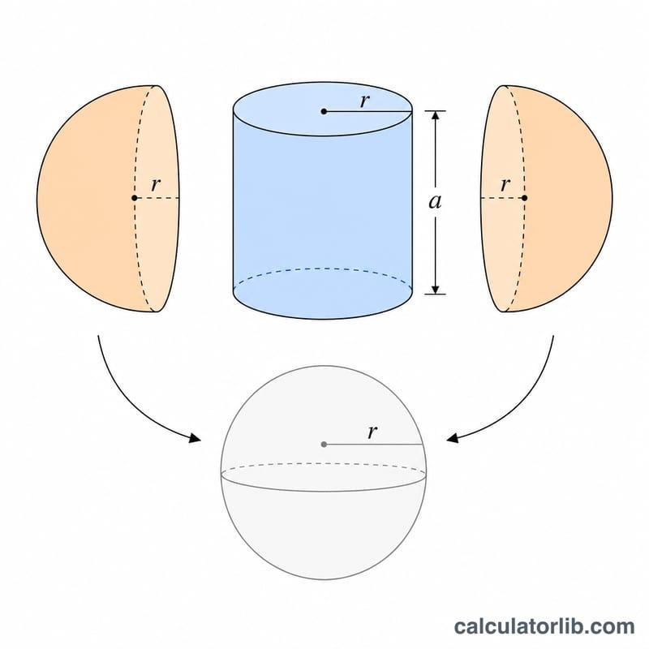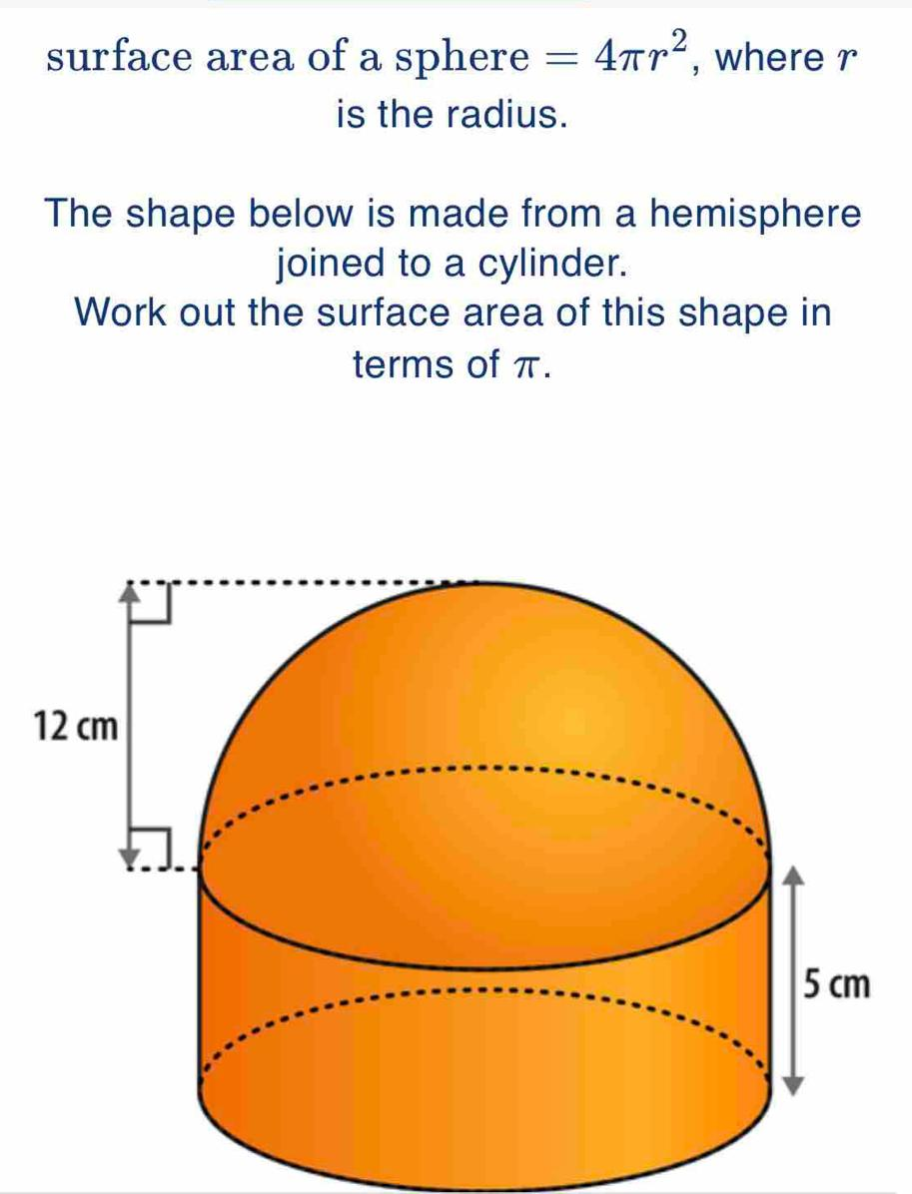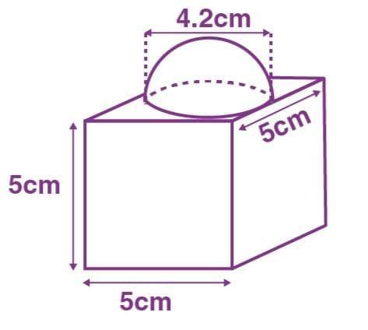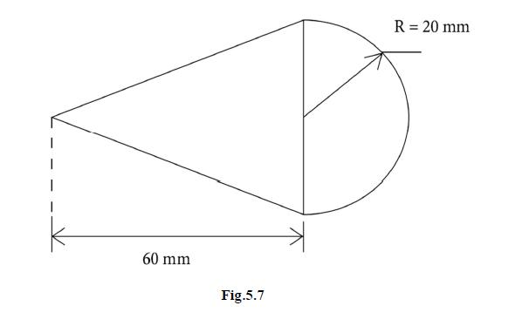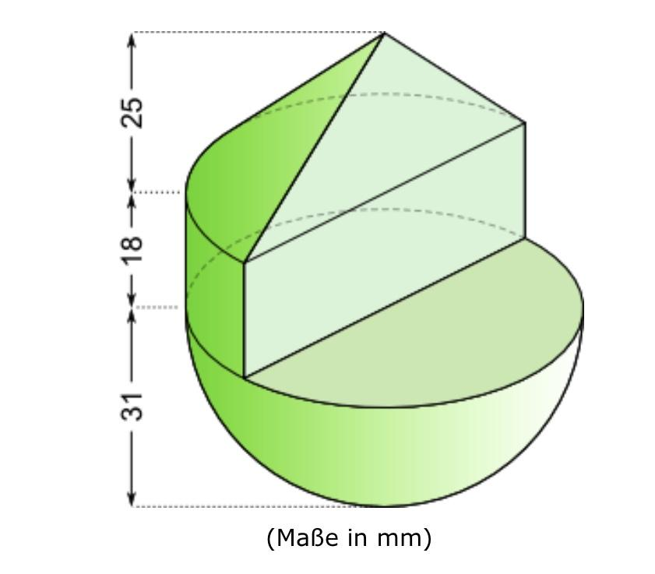
Examples:
- A sphere attached to a hemisphere.
- A sphere combined with two hemispheres.
- Multiple hemispherical components arranged around a spherical component.

Sphere-and-Prism Composite Solids
# Source: AI Source: Provided by: [Data Path: Persons Table -> ID Column: 1, Name_En Column: Motasem Essam] -> From: [ChatGPT] on [7/25/2026]
These solids combine spherical components with prism-based components.
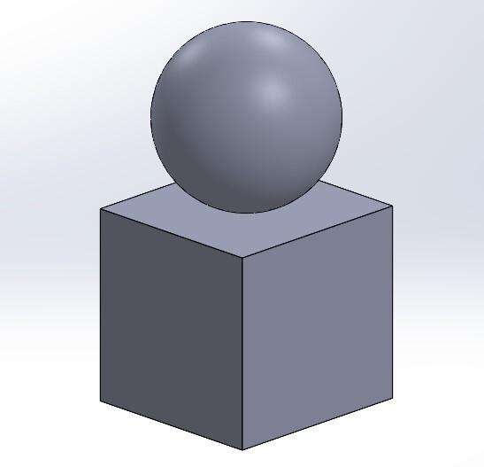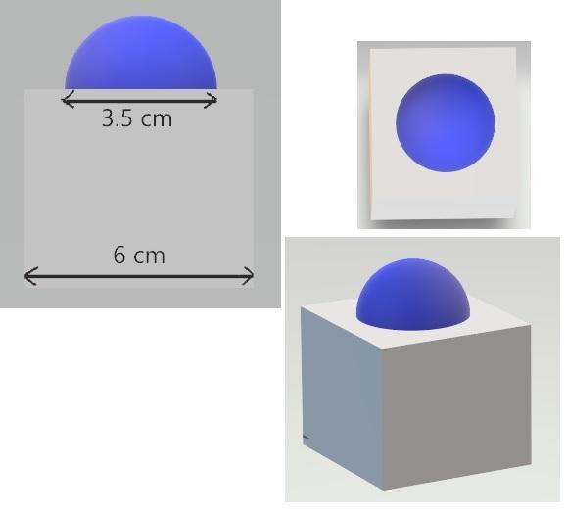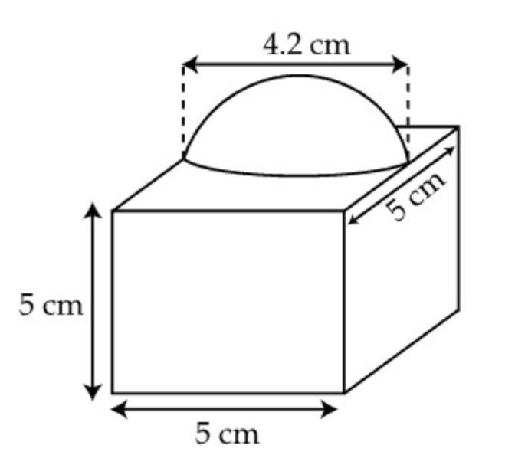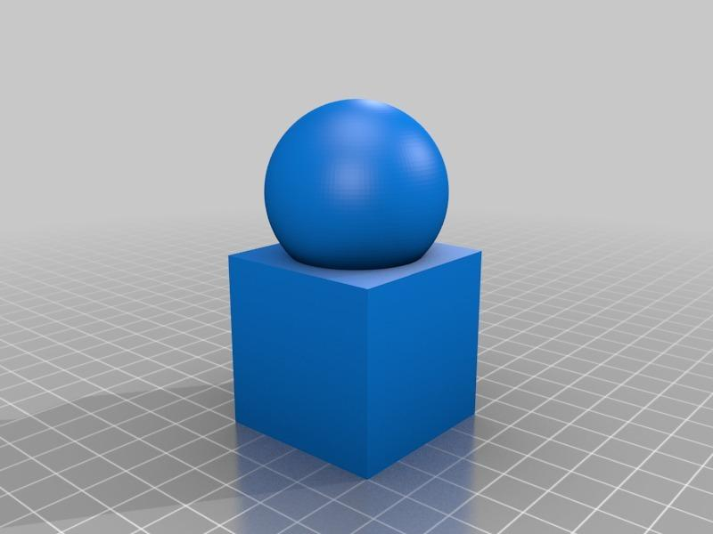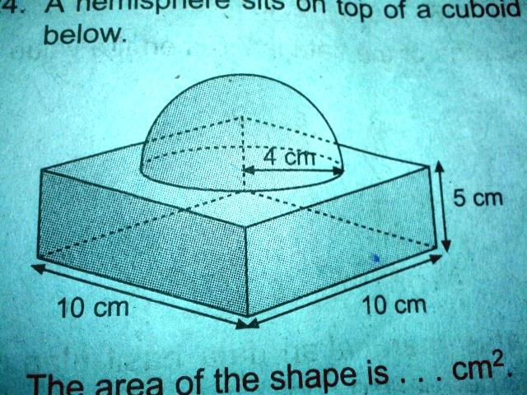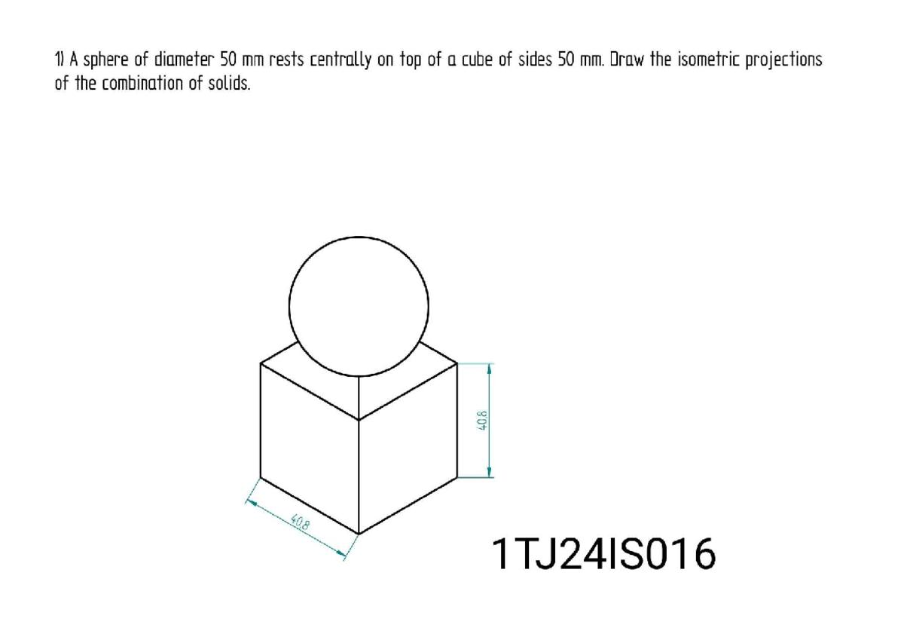
Examples:
- A sphere placed on a cube.
- A hemisphere attached to a rectangular prism.
- A spherical cap attached to a prism through a matching circular region.

Sphere-and-Cylinder Composite Solids
# Source: AI Source: Provided by: [Data Path: Persons Table -> ID Column: 1, Name_En Column: Motasem Essam] -> From: [ChatGPT] on [7/25/2026]
These solids combine spheres or hemispheres with cylindrical components.
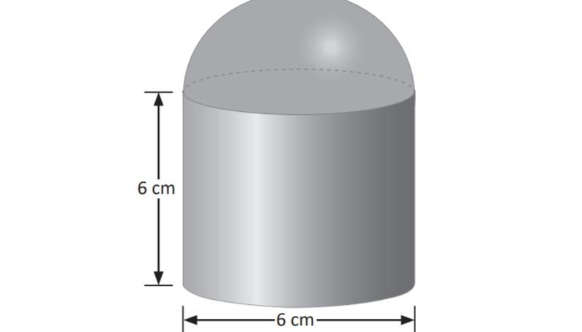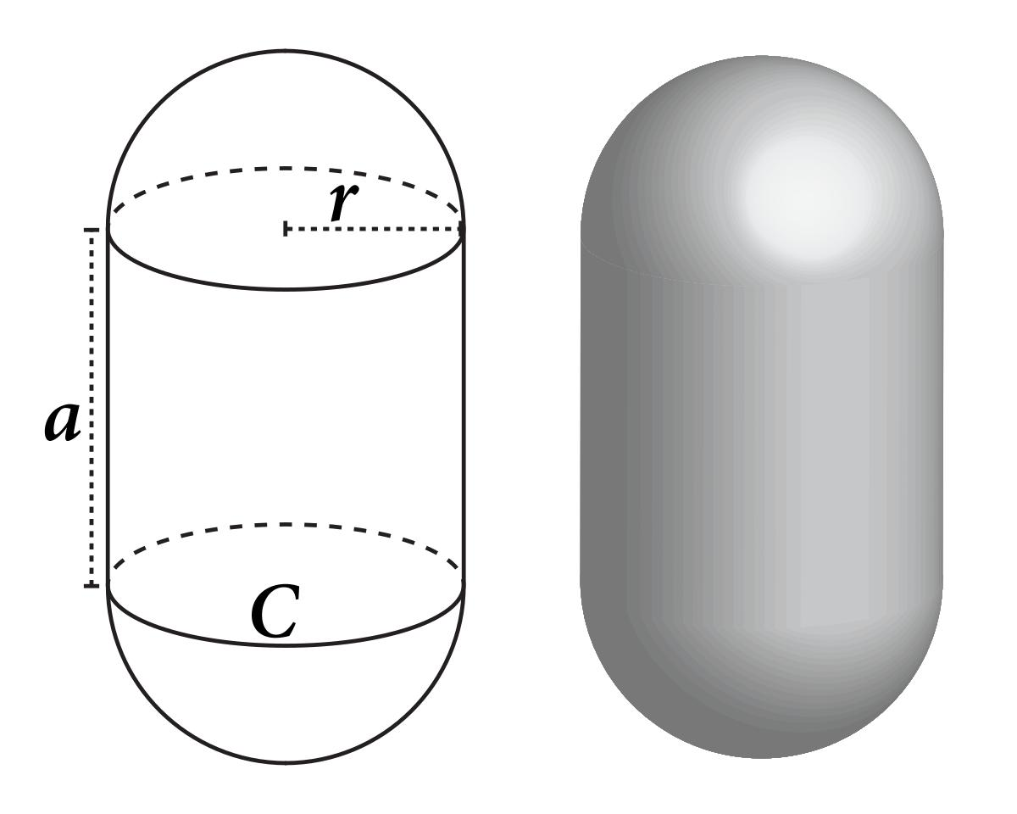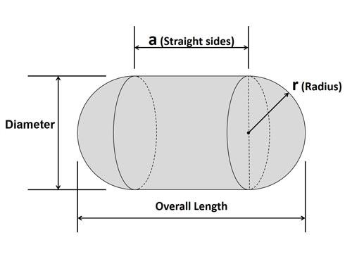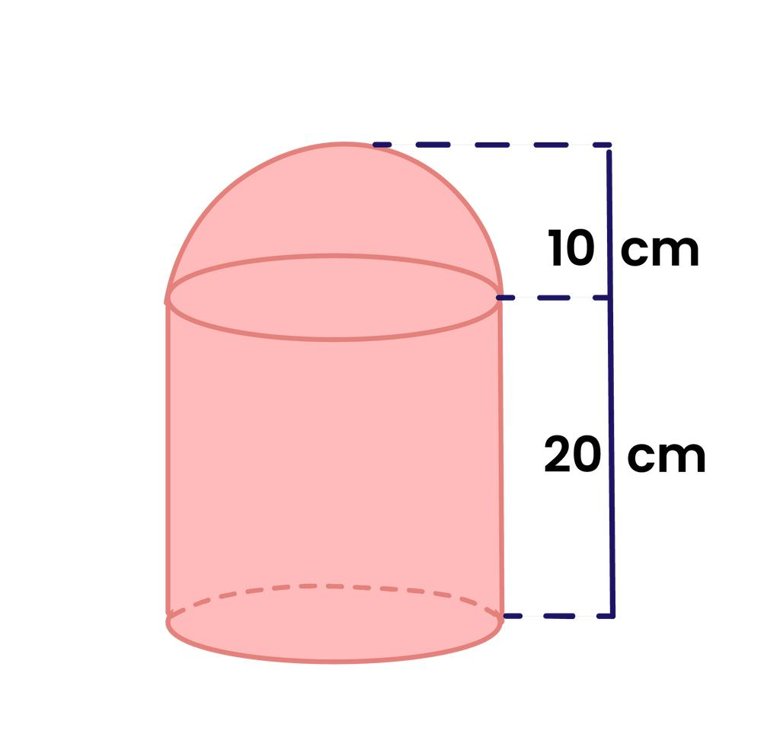
Examples:
- A hemisphere placed on a cylinder.
- A sphere attached to a cylinder.
- A cylinder with a hemisphere at each end.
- A cylindrical body combined with spherical end sections.

Sphere-and-Cone Composite Solids
# Source: AI Source: Provided by: [Data Path: Persons Table -> ID Column: 1, Name_En Column: Motasem Essam] -> From: [ChatGPT] on [7/25/2026]
These solids combine spherical components with conical components.
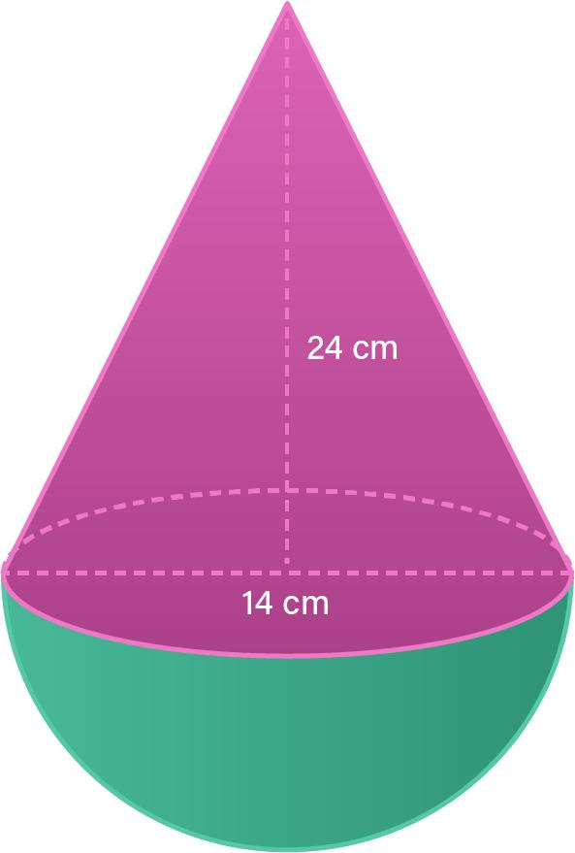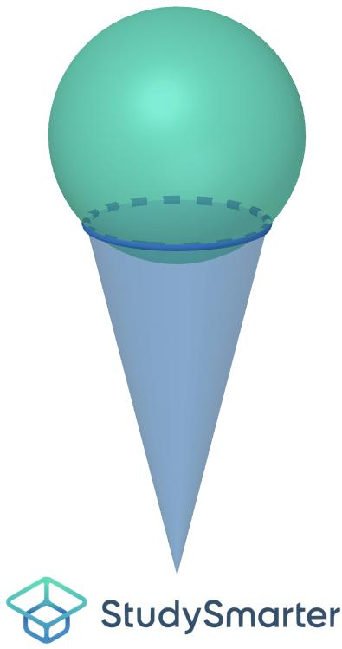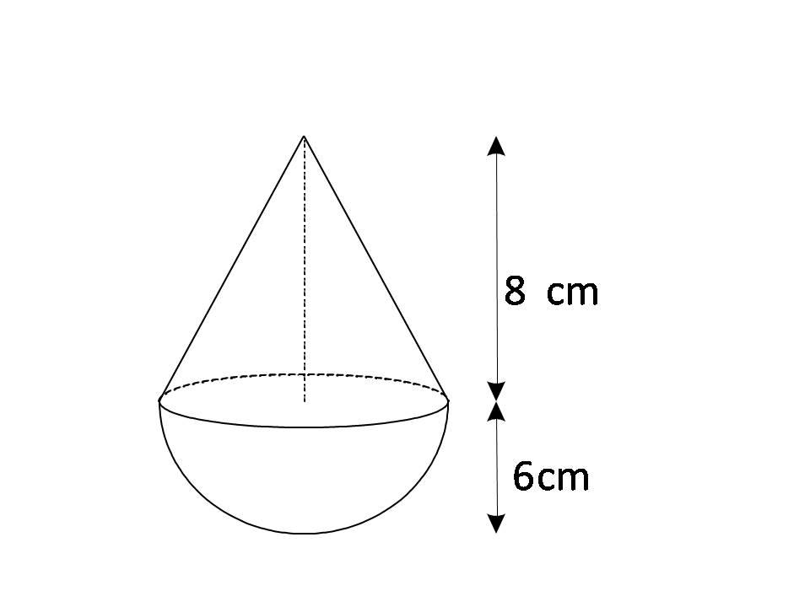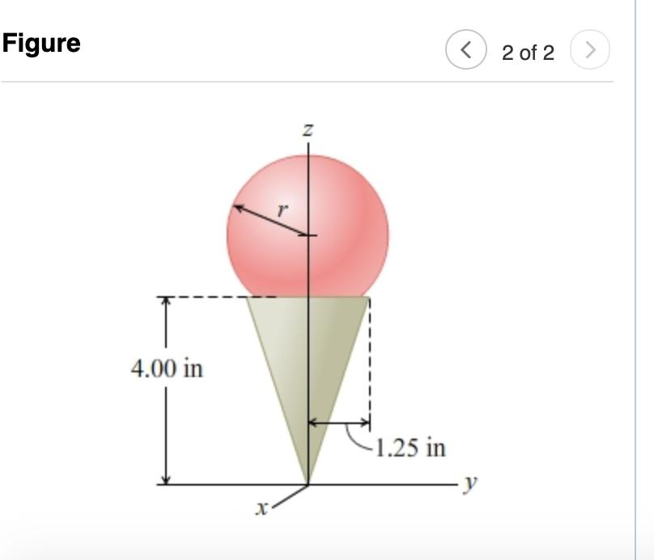
Examples:
- A sphere attached to a cone.
- A hemisphere connected to a cone.
- A cone combined with a spherical cap.

Multiple-Sphere Composite Solids
# Source: AI Source: Provided by: [Data Path: Persons Table -> ID Column: 1, Name_En Column: Motasem Essam] -> From: [ChatGPT] on [7/25/2026]
These solids contain several spherical components arranged in a specific geometric pattern.
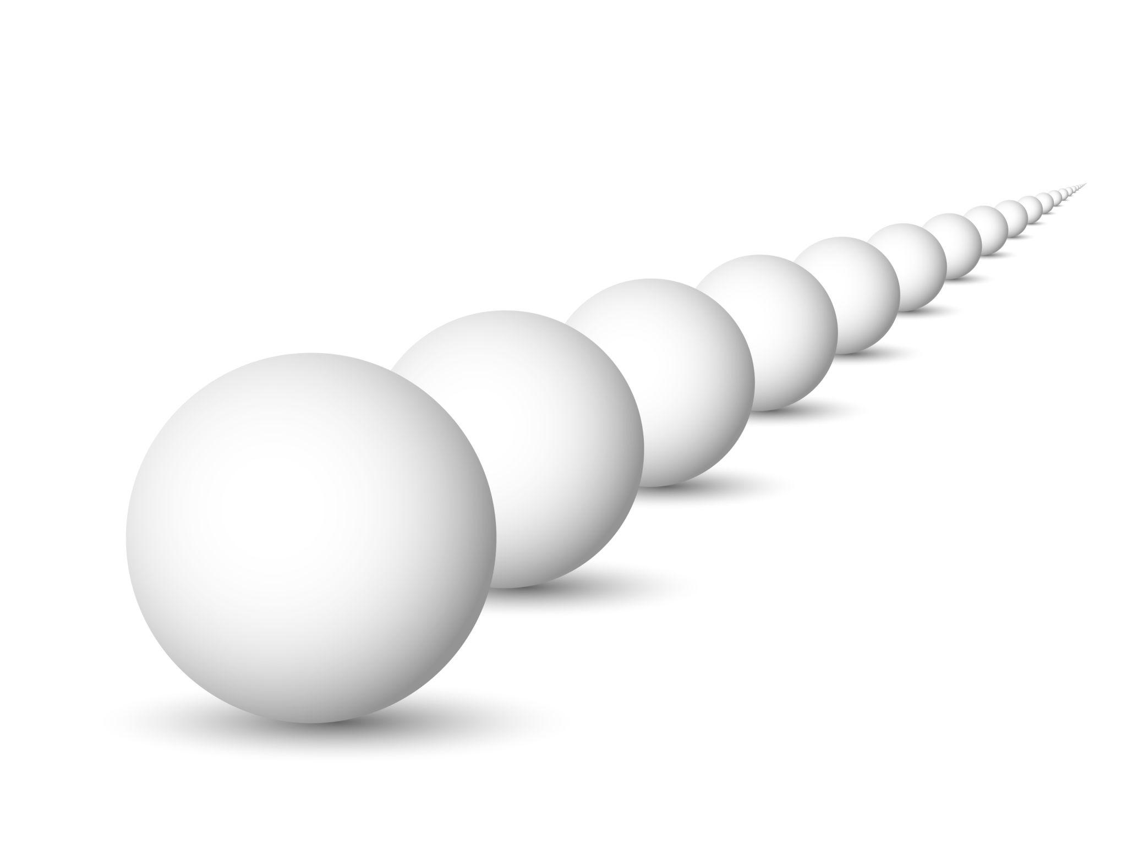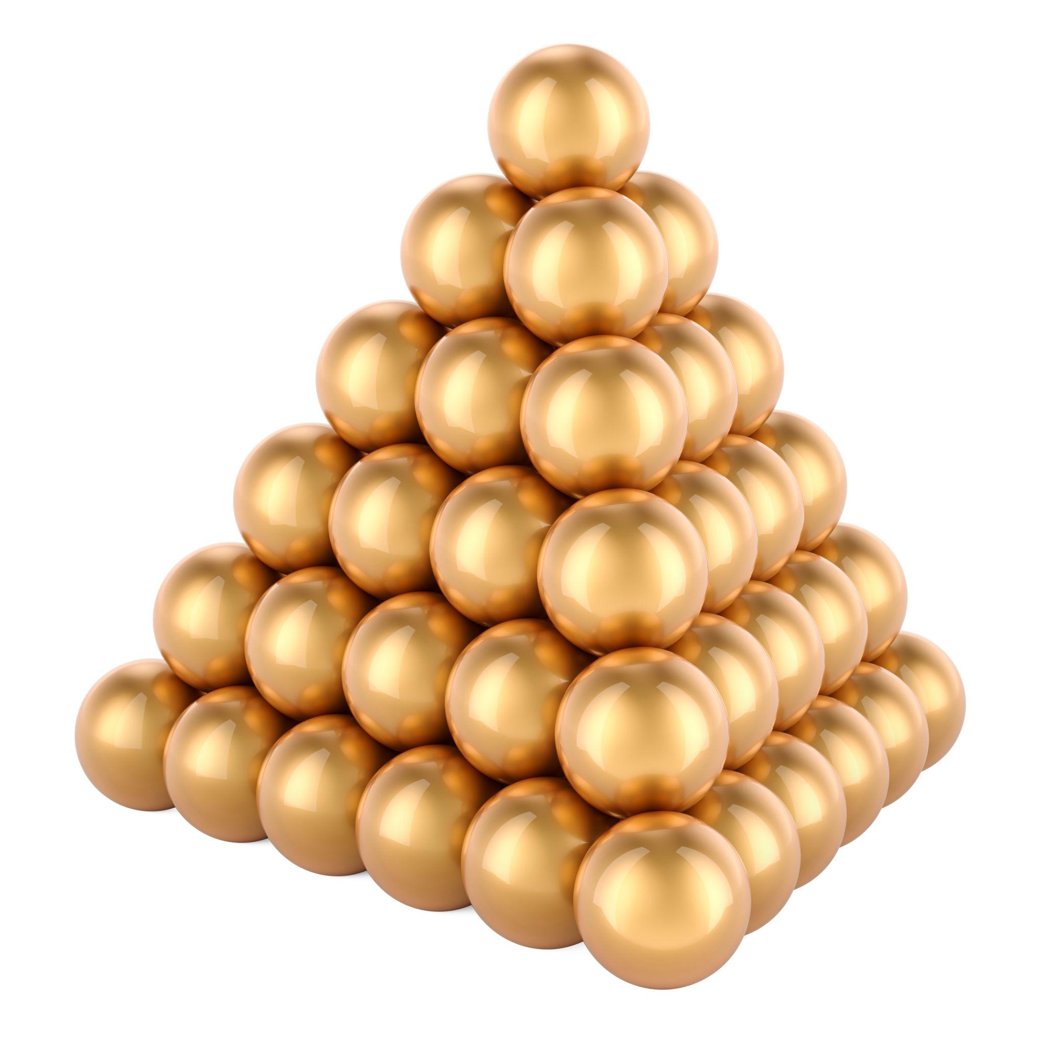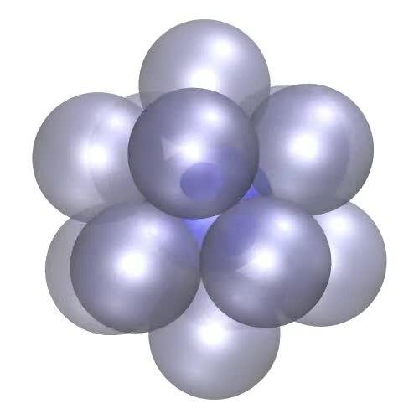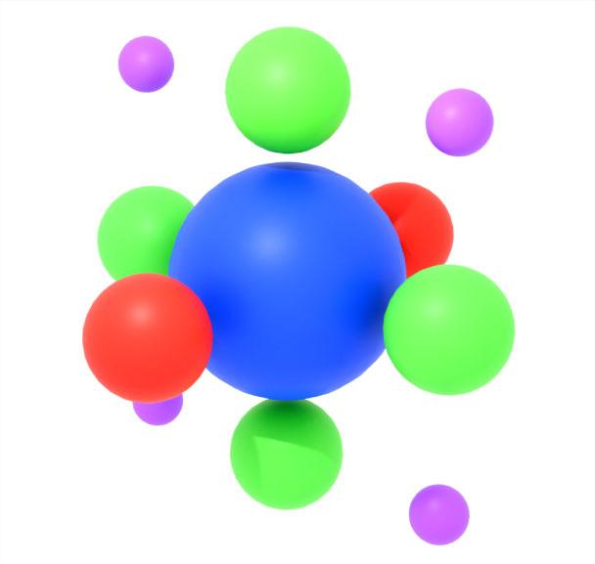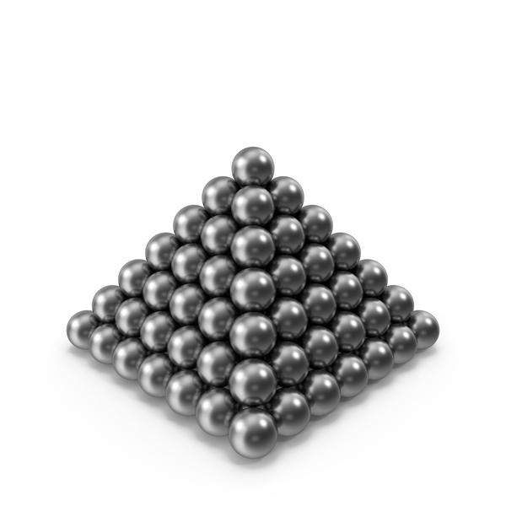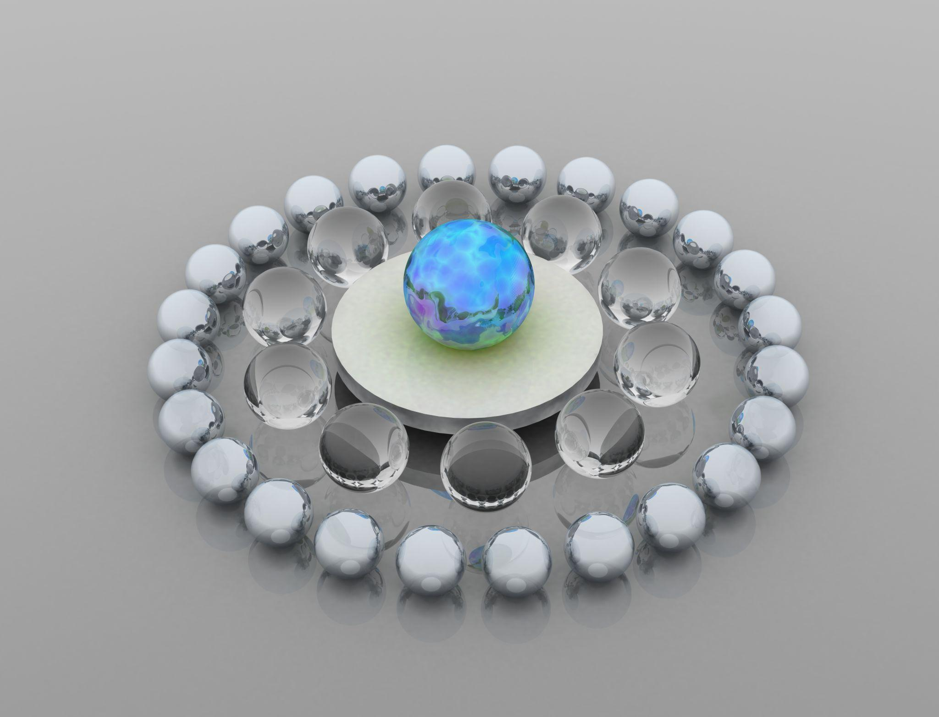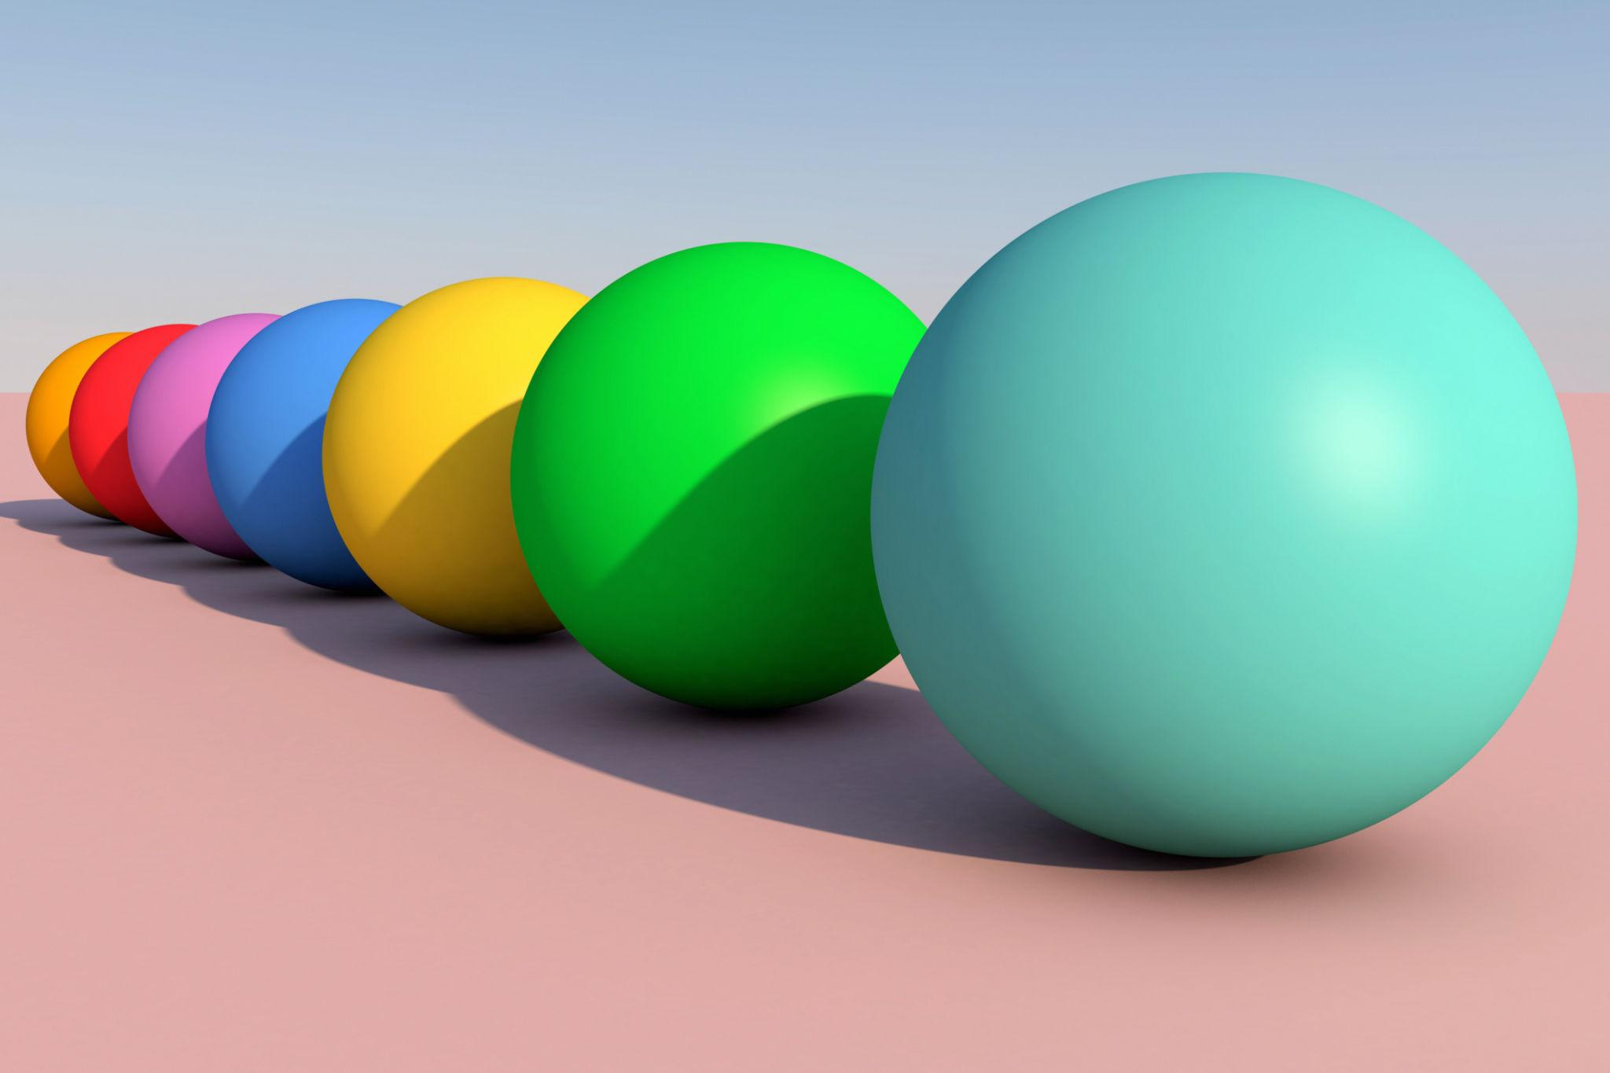
Examples:
- Spheres arranged in a linear pattern.
- Spheres arranged in a triangular or grid pattern.
- Spheres arranged around a central sphere.
- Concentric spherical components with different radii.

Mixed Sphere-Based Composite Solids
# Source: AI Source: Provided by: [Data Path: Persons Table -> ID Column: 1, Name_En Column: Motasem Essam] -> From: [ChatGPT] on [7/25/2026]
These solids combine spheres with different types of geometric components, such as prisms, cylinders, cones, and other curved solids.
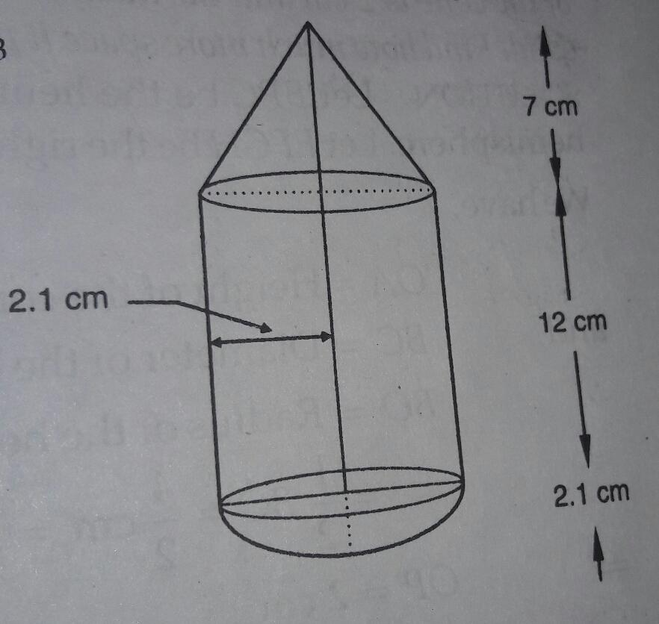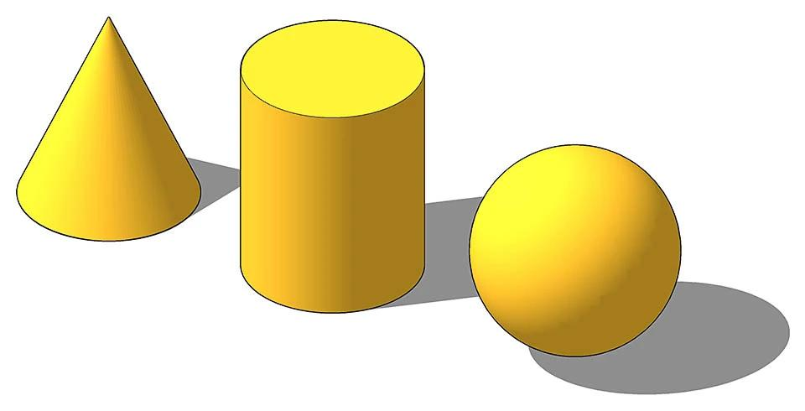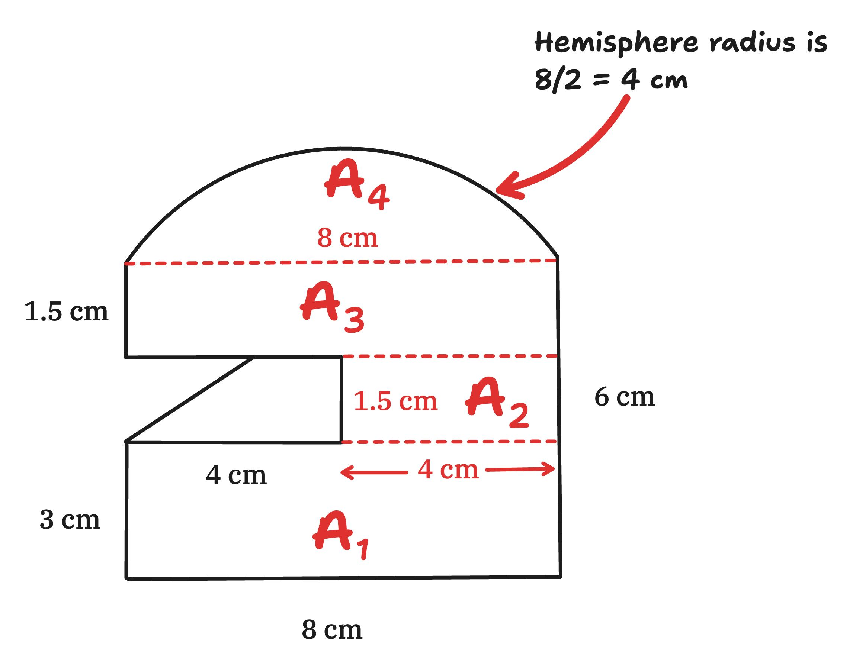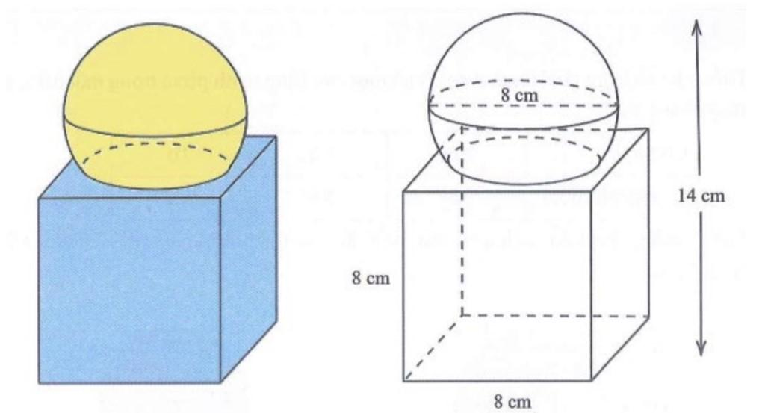
Examples:
- Sphere + cylinder + cone.
- Hemisphere + rectangular prism + cylinder.
- Multiple spheres combined with different polyhedra.
- Spherical components combined with curved and flat surfaces.

Classification by Joining Arrangement
# Source: AI Source: Provided by: [Data Path: Persons Table -> ID Column: 1, Name_En Column: Motasem Essam] -> From: [ChatGPT] on [7/25/2026]
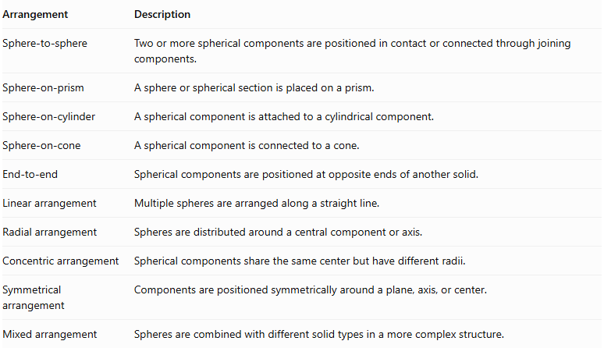
Arrangement | Description
Sphere-to-sphere | Two or more spherical components are positioned in contact or connected through joining components.
Sphere-on-prism | A sphere or spherical section is placed on a prism.
Sphere-on-cylinder | A spherical component is attached to a cylindrical component.
Sphere-on-cone | A spherical component is connected to a cone.
End-to-end | Spherical components are positioned at opposite ends of another solid.
Linear arrangement | Multiple spheres are arranged along a straight line.
Radial arrangement | Spheres are distributed around a central component or axis.
Concentric arrangement | Spherical components share the same center but have different radii.
Symmetrical arrangement | Components are positioned symmetrically around a plane, axis, or center.
Mixed arrangement | Spheres are combined with different solid types in a more complex structure.

Classification by Spherical Component Dimensions
# Source: AI Source: Provided by: [Data Path: Persons Table -> ID Column: 1, Name_En Column: Motasem Essam] -> From: [ChatGPT] on [7/25/2026]
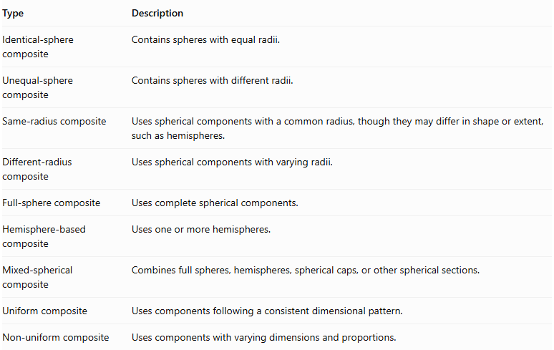
Type | Description
Identical-sphere composite | Contains spheres with equal radii.
Unequal-sphere composite | Contains spheres with different radii.
Same-radius composite | Uses spherical components with a common radius, though they may differ in shape or extent, such as hemispheres.
Different-radius composite | Uses spherical components with varying radii.
Full-sphere composite | Uses complete spherical components.
Hemisphere-based composite | Uses one or more hemispheres.
Mixed-spherical composite | Combines full spheres, hemispheres, spherical caps, or other spherical sections.
Uniform composite | Uses components following a consistent dimensional pattern.
Non-uniform composite | Uses components with varying dimensions and proportions.

Mathematical Properties and Formulas

Volume of a Sphere-Based Composite Solid
# Source: AI Source: Provided by: [Data Path: Persons Table -> ID Column: 1, Name_En Column: Motasem Essam] -> From: [ChatGPT] on [7/25/2026]
The total volume is the sum of the volumes of its components when their interiors do not overlap.
$$V_{total}=V_{1}+V_{2}+⋯+V_{n}$$
The volume of a sphere is:
$$\boxed{V=\frac{4}{3}πr^{3}}$$
Where:
- $V$ = sphere volume.
- $r$ = sphere radius.
The volume of a hemisphere is:
$$V=\frac{2}{3}πr^{3}$$
The volume of a cylinder is:
$$V=πr^{2}h$$
The volume of a cone is:
$$V=\frac{1}{3}πr^{2}h$$
For a composite solid containing spheres and other solids:
$$V_{total}=\sum{V_{spherical components}}+\sum{V_{other components}}$$
If components overlap in volume, subtract the overlapping region to avoid double-counting.

Surface Area of a Sphere-Based Composite Solid
# Source: AI Source: Provided by: [Data Path: Persons Table -> ID Column: 1, Name_En Column: Motasem Essam] -> From: [ChatGPT] on [7/25/2026]
The surface area of a sphere is:
$$\boxed{SA=4πr^{2}}$$
The curved surface area of a hemisphere is:
$$CSA=2πr^{2}$$
The total surface area of a hemisphere, including its flat circular base, is:
$$SA=3πr^{2}$$
For a composite solid, only the exposed surfaces are counted. Hidden joining surfaces are excluded.
For two components joined through a matching planar interface:
$${SA}_{total}={SA}_{1}+{SA}_{2}-2A_{contact}$$
This formula applies when the components share a complete planar joining face. For intersecting spheres or other curved intersections, calculate the actual exposed spherical and curved surfaces instead.

Useful Spherical Measurements
# Source: AI Source: Provided by: [Data Path: Persons Table -> ID Column: 1, Name_En Column: Motasem Essam] -> From: [ChatGPT] on [7/25/2026]
Sphere diameter:
$$d=2r$$
Sphere surface area in terms of diameter:
$$SA=πd^{2}$$
Sphere volume in terms of diameter:
$$V=\frac{πd^{3}}{6}$$
Hemisphere curved surface area:
$$CSA=2πr^{2}$$

Worked Examples

Example 1: Hemisphere Joined to a Cylinder
# Source: AI Source: Provided by: [Data Path: Persons Table -> ID Column: 1, Name_En Column: Motasem Essam] -> From: [ChatGPT] on [7/25/2026]
Given:
- Cylinder radius = $3 cm$.
- Cylinder height = $8 cm$.
- Hemisphere radius = $3 cm$.
The hemisphere is placed on top of the cylinder, sharing the same circular base.
Step 1: Calculate the cylinder volume.
$$V_{cylinder}=πr^{2}h$$
$$=π(3)^{2}(8)=72π$$
Step 2: Calculate the hemisphere volume.
$$V_{hemisphere}=\frac{2}{3}πr^{3}$$
$$=\frac{2}{3}π(3)^{3}=18π$$
Step 3: Calculate the total volume.
$$V_{total}=72π+18π$$
$$\boxed{V_{total}=90π≈282.74{ cm}^{3}}$$
Step 4: Calculate the external surface area.
The exposed surfaces are:
- Cylinder's curved lateral surface.
- Cylinder's bottom circular base.
- Hemisphere's curved surface.
Cylinder lateral surface:
$$2πrh=2π(3)(8)=48π$$
Cylinder bottom base:
$$πr^{2}=9π$$
Hemisphere curved surface:
$$2πr^{2}=18π$$
Therefore:
$${SA}_{total}=48π+9π+18π$$
$$\boxed{{SA}_{total}=75π≈235.62{ cm}^{2}}$$
<badge color="success">Final result</badge>
- Total Volume ≈ $282.74{ cm}^{3}$
- External Surface Area ≈ $235.62{ cm}^{2}$

Example 2: Cylinder with Two Hemispherical Ends
# Source: AI Source: Provided by: [Data Path: Persons Table -> ID Column: 1, Name_En Column: Motasem Essam] -> From: [ChatGPT] on [7/25/2026]
Given:
- Cylinder radius = $2 cm$.
- Cylinder length = $6 cm$.
- Two hemispherical ends, each with radius $2 cm$.
The two hemispheres together form one complete sphere.
Step 1: Calculate the cylinder volume.
$$V_{cylinder}=πr^{2}h$$
$$=π(2)^{2}(6)=24π$$
Step 2: Calculate the volume of the two hemispheres.
$$V_{two hemispheres}=2(\frac{2}{3}πr^{3})$$
$$=\frac{4}{3}π(2)^{3}=\frac{32}{3}π$$
Step 3: Calculate the total volume.
$$V_{total}=24π+\frac{32}{3}π$$
$$\boxed{V_{total}=\frac{104}{3}π≈108.91{ cm}^{3}}$$
Step 4: Calculate the external surface area.
The exposed surfaces are:
- Cylinder's curved lateral surface.
- Two hemispherical curved surfaces.
Cylinder lateral surface:
$${SA}_{cylinder lateral}=2πrh$$
$$=2π(2)(6)=24π$$
Two hemispherical curved surfaces:
$${SA}_{hemispheres}=2(2πr^{2})$$
$$=4π(2)^{2}=16π$$
Therefore:
$${SA}_{total}=24π+16π$$
$$\boxed{{SA}_{total}=40π≈125.66{ cm}^{2}}$$
<badge color="success">Final result</badge>
- Total Volume ≈ $108.91{ cm}^{3}$
- External Surface Area ≈ $125.66{ cm}^{2}$

Important Characteristics
# Source: AI Source: Provided by: [Data Path: Persons Table -> ID Column: 1, Name_En Column: Motasem Essam] -> From: [ChatGPT] on [7/25/2026]
- Spherical Components: These solids contain one or more spheres or spherical sections.
- Curved Surfaces: Spherical components contribute curved external surfaces.
- Variable Radii: Components may have equal or different radii.
- Different Arrangements: Spheres can be positioned linearly, radially, concentrically, or symmetrically.
- Mixed Geometric Components: Spheres can be combined with prisms, cylinders, cones, and other solids.
- Volume Addition: Component volumes can be added when their interiors do not overlap.
- External Surface Area: Only exposed portions of spherical and other surfaces are counted.
- Spherical Sections: Composite solids may contain complete spheres, hemispheres, spherical caps, and other spherical sections.
- Symmetry: Some sphere-based composite solids have rotational, axial, or spherical symmetry.
- Variable Contact Regions: Components may meet through planar interfaces, curved intersections, or point contacts.

Comparison with Other Types of Composite Solids
# Source: AI Source: Provided by: [Data Path: Persons Table -> ID Column: 1, Name_En Column: Motasem Essam] -> From: [ChatGPT] on [7/25/2026]
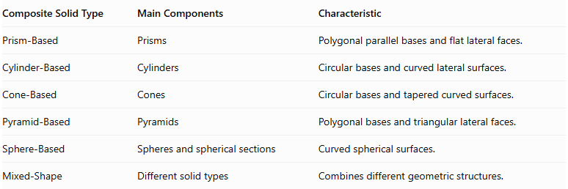
Composite Solid Type | Main Components | Characteristic
Prism-Based | Prisms | Polygonal parallel bases and flat lateral faces.
Cylinder-Based | Cylinders | Circular bases and curved lateral surfaces.
Cone-Based | Cones | Circular bases and tapered curved surfaces.
Pyramid-Based | Pyramids | Polygonal bases and triangular lateral faces.
Sphere-Based | Spheres and spherical sections | Curved spherical surfaces.
Mixed-Shape | Different solid types | Combines different geometric structures.

Applications
# Source: AI Source: Provided by: [Data Path: Persons Table -> ID Column: 1, Name_En Column: Motasem Essam] -> From: [ChatGPT] on [7/25/2026]
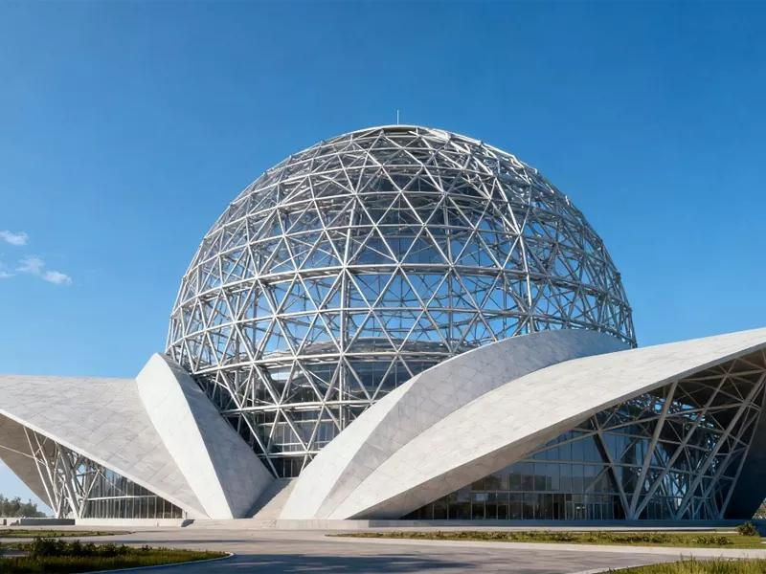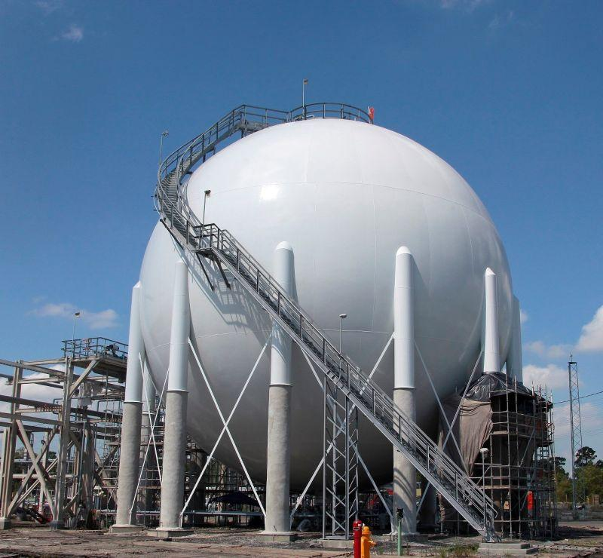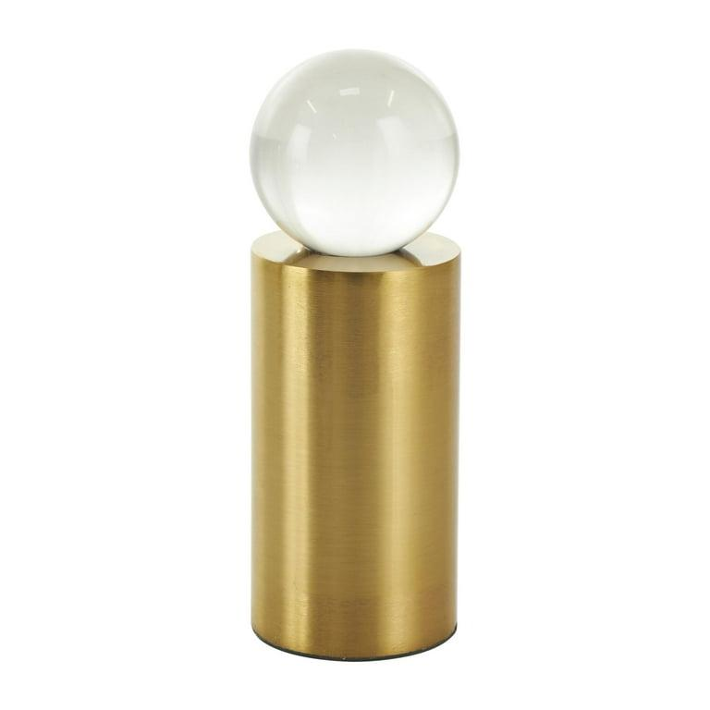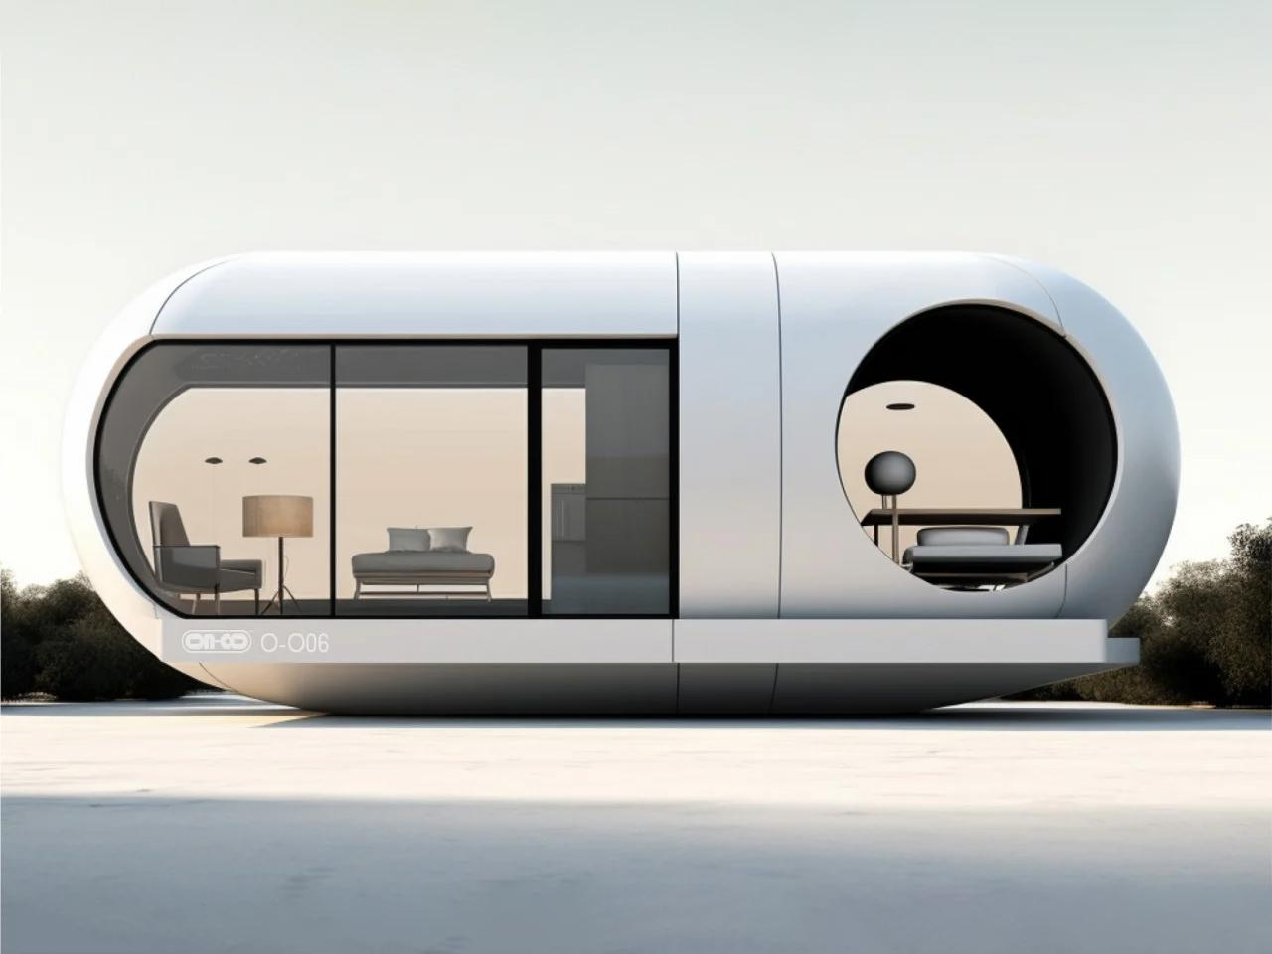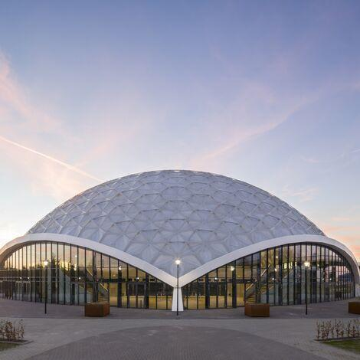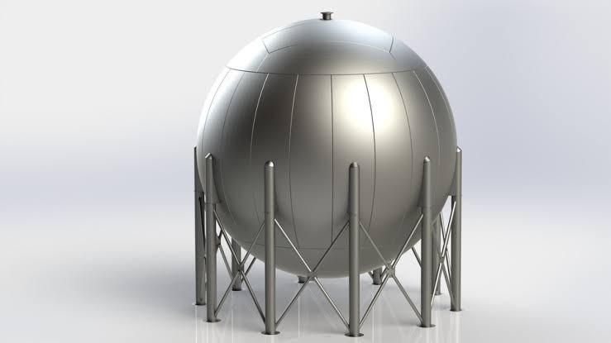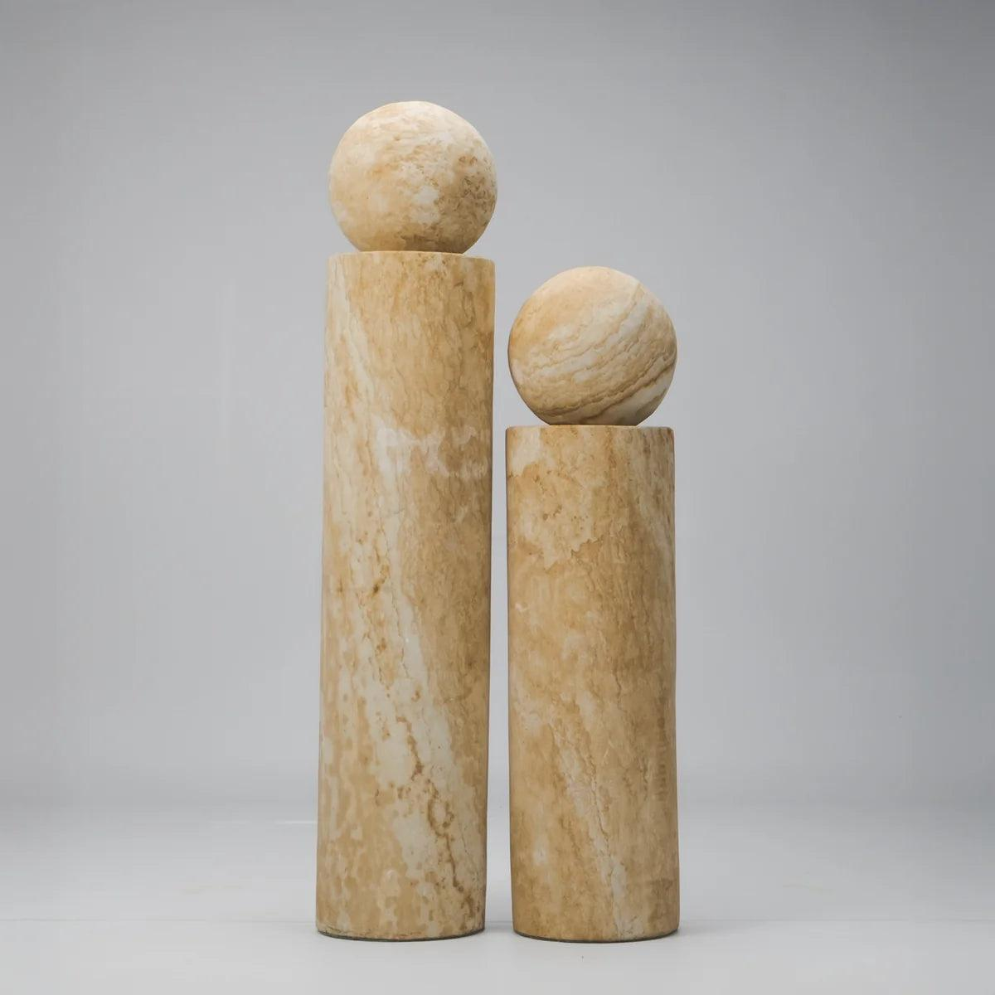
Sphere-based composite solids are used in several fields:
- Architecture: Spherical domes, decorative structures, and rounded building components.
- Engineering: Pressure vessels, spherical tanks, and storage containers.
- Product Design: Capsule-shaped products, spherical decorations, and rounded equipment.
- Mechanical Design: Bearings, spherical joints, and rotating components.
- Mathematical Models: Teaching spherical volume, surface area, and three-dimensional composition.
- Computer Graphics: Modeling planets, spherical structures, and complex curved objects.

Key Points
# Source: AI Source: Provided by: [Data Path: Persons Table -> ID Column: 1, Name_En Column: Motasem Essam] -> From: [ChatGPT] on [7/25/2026]
- Sphere-based composite solids combine spheres with other spheres or geometric solids.
- Their components may include full spheres, hemispheres, and spherical sections.
- Common arrangements include linear, radial, concentric, symmetrical, and mixed arrangements.
- The volume of a sphere is:
$$V=\frac{4}{3}πr^{3}$$
- The surface area of a sphere is:
$$SA=4πr^{2}$$
- The volume of a hemisphere is:
$$V=\frac{2}{3}πr^{3}$$
- The curved surface area of a hemisphere is:
$$CSA=2πr^{2}$$
- Volume calculations must account for overlapping regions.
- Surface area calculations must exclude hidden joining surfaces and include only exposed surfaces.

Conclusion
# Source: AI Source: Provided by: [Data Path: Persons Table -> ID Column: 1, Name_En Column: Motasem Essam] -> From: [ChatGPT] on [7/25/2026]
Sphere-Based Composite Solids are an important category of composite solids formed by addition. They are created by combining spherical components with other spheres or geometric solids, such as prisms, cylinders, and cones.
Their structures can vary according to the number of spherical components, their radii, their arrangements, and the types of solids connected to them. Understanding these structures helps in calculating volume, determining external surface area, and analyzing complex three-dimensional geometric objects.

